JULIE HEFFERNAN
COURTESY CATHARINE CLARK GALLERY

Self-Portrait as Hothead, 2019
Oil on canvas, 78 x 64 in.

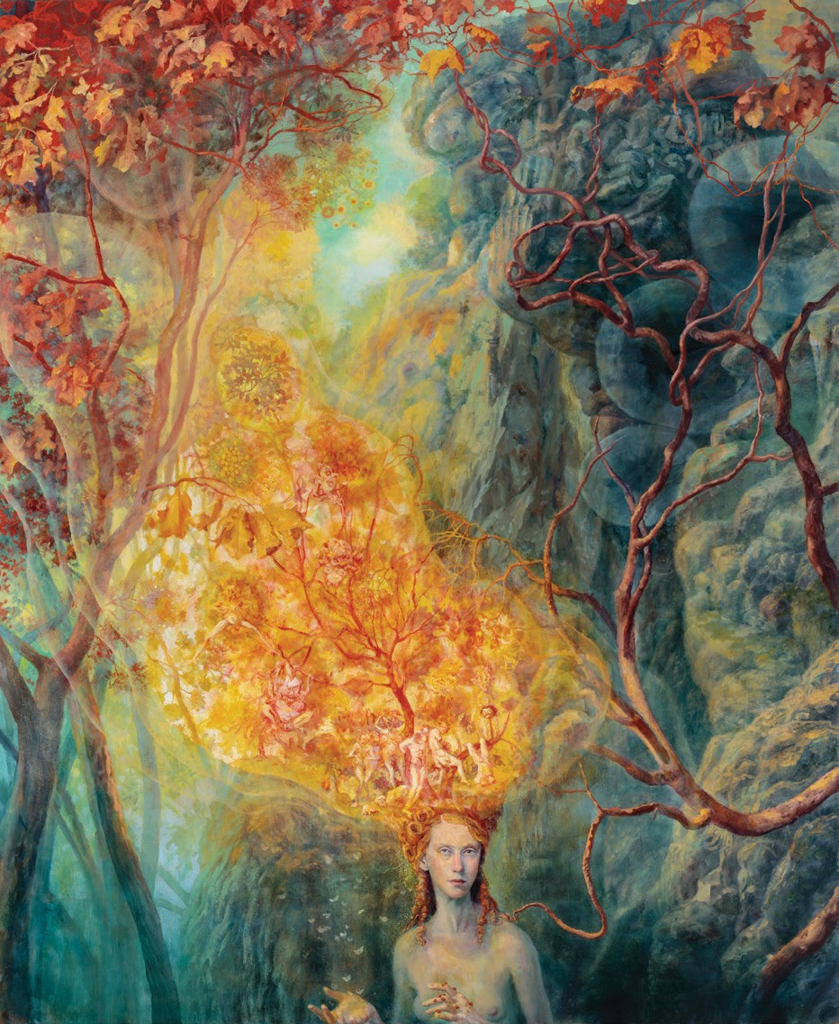

MARIA KOCHIS
Wild Nights
hen Dan walked into the kitchen, I could tell right away he’d been with Diego in the vines. He had his faded-to-nearly-white
denim jacket on, his stiff cowboy hat with the leather braids wound around the crown. Grape leaves plastered to the cuffs of his jeans. I walked over and kissed his cold cheeks. “Listen,” he said. “The Lawsons are coming for dinner.”
W
“What? Tonight?” He nodded warily.
I glared at him and crossed my arms. “But I don’t like the Lawsons. I think they poisoned that coyote. The big male? With the really beautiful coat? I haven’t seen him around for months.”
The coyote had begun showing up several years ago, cruising around the perimeter of our property like he was making some kind of inspection. I saw him most often around sunset, trotting the northern ridgeline. The Law- sons’s property backed up to ours, and I remember how much the coyote worried Lucy when her sheep started lambing. She had Stanley, her husband, checking their fence constantly for holes.
“Well you can ask them about it when they come over for dinner.” The merest lift to Dan’s lips, so I’d know he was kidding.
He had been at the farmers’ market yesterday when he ran into Lucy. He asked how they were enjoying their second winter here, and it all came out. The never-ending rain. The unfriendliness of folk. How many times had she asked people to call on her and Stanley? Were people that uppity in the valley? That closed?
Stanley finally came over with a bag of late-season tomatoes, embarrassed, Dan could see it, about his wife’s running lament, and Dan had issued the invitation out of sympathy for the man and to give Lucy something to focus on.
“Fine,” I said. “But we’re having goulash.” “Goulash?” Dan walked over to the sink, turned on
the faucet, and washed his hands, sudsing them up and scrubbing his knuckles, rubbing his palms together fast. Our grapes were all organic, but the vineyard west of us used pesticides, they had an even bigger spread than ours, and the wind too often came from their direction.
“Unless you’d rather have omelets?”
“What if the Lawsons don’t like mushrooms?”

CATAMARAN 73

“Then they don’t have to eat them.”
“What if . . . what if there’s a bad one in there?” “There’s not.” I walked over to the table. There, in the
bowl, was the fruit of my morning’s labor: flaring chan- terelles, maple-scented candy caps, gemmed puffballs, and witches’ butter. A feast for the tongue. A bounty of micronutrients.
* * *
The Lawsons arrived late. In fact, I was starting to think they wouldn’t show at all, that we would have the whole evening to ourselves, when they finally pulled up in the driveway.
“Your table looks . . . how pretty! All this trouble for us!” Lucy stood still, put her fingers to her mouth.
“Of course! Dan, can you put their pie in the fridge?” I moved around the table to give Lucy a hug, her big breasts squashing into my rib cage, and then Stanley, hovering behind her, who might have given me the gentlest hug I’d ever received from a man.
I spooned out the goulash. Dan opened the wine. One of our finest cab reserves, dating back to 2007, a great year for cabs around here. He must have squirreled it away in the cellar. I didn’t think we had any more left. I raised my eyebrows at him, but he pretended not to see.
For a moment, we were all silent, sipping and swirl- ing. Lucy closed her eyes, she was so appreciative, so I had a moment to look at her. Look at her again. One looked to figure out exactly why she wasn’t pretty. Her features weren’t bad: large eyes, full lips, one of those cute upturned noses that sharpened at the end, almost to a point, but her features all yearned toward her forehead, as if some large hand had pressed gently on her face when she was a baby and then moved slightly up. She didn’t wear her breasts to their best advantage, but I suppose she didn’t have to. I wasn’t worried. She wasn’t Dan’s type, which isn’t to say he didn’t have one.
Out of the corner of my eye, I noticed my husband’s trembling hand. It made me so horny, watching Dan eat my mushrooms. I don’t mean the actual forking into his mouth. I mean the way his face suddenly lost all certainty. I had also made a spread, tossing some of the chanterelles into the blender with seven cloves of garlic and our neigh- bor’s olive oil, adding a tin of caviar.
“Dan told me the two of you used to farm near Esparto,” Stanley said.
“I didn’t know that!” Lucy put her cracker down. “What was that like? I’ve heard great things about the Capay Valley!”
Dan left me to unspool the story, so I told it the way I remembered. Twenty acres of floodplain that never stopped producing. Vegetables and flowers. Heirloom chickens and thirty beehives. Every Sunday, I drove to Sacramento and sold everything I could at the big market on X Street. I heard a term once, I can’t remember where, or maybe I read it. Sacred existence. That’s what I thought we had, even though we worked our asses off, sunrise to sundown, and barely broke even.
“And what were the people like?” Lucy was asking. “Were your neighbors friendly sorts?”
I shrugged. “Most of them were. But there were some real assholes in the valley, too.” An idea was forming in my head, one I couldn’t keep down.
“Some of them, for instance, were coyote killers.” Lucy was looking at me wide-eyed.
“Hiking, I would come across their skins hanging on a fence, all in a line,” I said. “Tails dusting the ground. Eyes pecked out by the ravens. ” Even dead, those coyotes were beautiful. Sometimes, to dull my pain, I told myself their spirits were still roaming the parched hills, slipping quiet as shadows through the moonlit orchards and stir- ring up the dogs.
Lucy raised a hand to her lips. “I think I feel sick,” she whispered. “Where’s . . . where’s the bathroom?”
Dan sprang up to show her. In another minute, we could all hear her retching.
* * *
The ride to the hospital, over in Napa, took thirty minutes, when normally it would have taken forty-five. But there was no traffic, and Stanley went ten miles over the speed limit and didn’t stop for lights. Dan and I followed in our truck. We didn’t talk much, but when we parked our truck, neither of us got out right away. Stanley had driven straight to the emergency room. I imagined he carried Lucy out of the car and into the hospital and left his truck running, the door wide open, for anyone to steal.
“I know what you’re thinking,” I finally said.
“What am I thinking?” My husband’s face turns white when he’s angry or frightened, and it was white as the moon now.
“You’re thinking it was one of my mushrooms that did
it.”
“Wasn’t it?”
“None of us are sick. We all ate the same thing, Dan.” Although none of us, it was true, seemed to have eaten as much as Lucy.
* * *
The lobby in the ER only had a few people in it: a young Hispanic family; an old woman rocking back and forth to the beat of her own prayers; a twentysomething guy with a very quiet, alert-looking terrier. Must have been an anxi- ety dog. The guy kept one of his hands deep in its scruff, as if he needed something to hold on to. I sat in a green plastic chair under the room’s only clock and Dan sat by the door. We didn’t see Stanley anywhere when we first came in, but half an hour or so later, he walked out of the swinging doors and headed straight for me. He was such a tall man that even on one knee, his long, bony face was even with mine.
“The doctor wants a list of everything Lucy ate in the past twenty-four hours,” he said. “Can you help?”
I thought carefully and wrote down all the ingredi- ents I had used for dinner, even the spices in the goulash. I wrote the common names for the mushrooms, as well as the scientific names. Stanley rushed the form to the woman at the desk and then sat in the chair next to me, his big hands flat on his thighs.
It wasn’t too long after that the doctor who was treating Lucy appeared and gestured for Stanley to join him. After a quick conversation, Stanley waved me over.
“These mushrooms you listed. Did you gather them wild?”
I told the doctor I did, trying to keep the defensiveness out of my voice.
“Is there any chance you could have served Mrs. Rear- don a jack-o’-lantern?”
I knew why he was asking. Jack-o’-lanterns are often mistaken for chanterelles. In the eclectic vocabulary of mushroom hunters, they’re often referred to as a looka- like. But an experienced forager can always tell them apart.
Chanterelles smell faintly like apricots; they grow straight out of the soil and have false, forked gills, which seem to melt into their stalks. Jack-o’-lanterns clump together and grow on dead wood. They have true gills and glow in the dark.
“I really don’t think so,” I said. “I’m very careful.” “What about one of the amanitas? A death cap, or a de-
stroying angel?”
“Absolutely not!” I could feel myself paling at the suggestion.
The doctor nodded and said there was a good chance Lucy had food poisoning of some sort. They would run some of the standard tests. Her nausea seemed to be abat- ing and all her vital signs looked good, so whatever it was, it probably wasn’t too serious.
* * *
When Dan and I got back to the house it was early morn- ing. Dawn light was spilling all over the table, reminding me of one of Vermeer’s kitchen scenes: messy, raw, but also holy. The wine in our glasses was very red. Chairs were pushed back, and the molten wax of the candles had run down their sides and gobbed along their holders. The air in the kitchen was thick with scent: the sour scent of the wine and the garlicky, earthy scent of the goulash.
Dan had coffee and then left for the vines. It was that critical time of year, just before the harvest. I knew that he would spend hours measuring sugars and acids with his refractometer, trying to determine if the grapes were fully ripe, and that when he came home that evening, his fingers and thumb would be stained deeply purple, and so would his tongue.
Dan and I had twenty hilly acres, almost all of which are given to grapes. We were able to buy the property with some money an aunt in Florida had left him. Our neigh- bors to the left and right also grow grapes, but behind us, Howell Mountain rises steeply; there is only woods. After I cleaned up the kitchen, I put on my boots and hiked two miles up a twisted, rooty trail to my secret place: a meadow, golden with grasses, fringed with Doug firs. Only one tree grows inside the perimeter of the meadow, an enormous coast live oak. At the base of this oak was a mattress, which used to grace our bedroom. No sheet. A pattern of red and white stripes. The mattress wouldn’t last the winter. The

74 Maria Kochis CATAMARAN 75

corners were black with mold. Mice had been eating it out from the inside. In November, I planned to haul it back down the trail in my wheelbarrow, take it to the dump.
In the old days, if I had shown Dan a mattress in the meadow, no matter how mouse-infested, he’d have had my clothes off in no time. Here, in Napa, sex was never that playful, or even that frequent. What Dan seemed to like instead was a smoldering fire. Letting things build. Days of looking, even touching, and then backing off. I still missed our old tussles, that puppy love of yore, but it was also true that the sex that had evolved between us was a lot more erotic: a pleasure I was always keening for.
The meadow and the woods around it, forty acres, be- long to Mr. Hatchets, who doesn’t live on Howell Moun- tain anymore but still shows up from time to time. He is supposedly a great birder and lover of oaks; his neighbors have begged him to sell his land for years and he won’t, not for love or money.
The coyote comes here too. Or used to. I knew it was the same animal because most coyotes aren’t that big. It was also a great thief and mischief maker. Once, when I was lying on the mattress in a spot of shifting sun, the coyote slunk by with a fat Rhode Island Red in its mouth. The hen was still alive and uncharacteristically quiet, full of surprise at being carried. Perhaps a warning light had gone off in its tiny chicken brain, instructing it not to make a sound. The coyote was close enough for me to see its pupils, the quivering whiskers of its nose. Another time, Dan and I were headed to a neighbor’s barbecue, when the coyote came trotting down the weedy shoulder of the driveway carrying a raw steak.
Dan and I had a good laugh at that. “The old trickster,”
he had said, not without affection.
I have always loved coyotes, the wiliest and most adapt- able of predators. When the coyote disappeared last spring, I felt bereft. Who would show me how to steal from my neighbors now, to smile in secret? Who would teach me how to survive this hyper-controlled landscape and still keep my wild soul intact?
* * *
I lounged on my mattress for several hours, reading and napping, watching the dark line of the woods. When I got home, I found a message from Stanley. Apparently, Lucy
had contracted a mild case of salmonella and would be just fine. I called him back, ready to apologize, but he cut me to the chase. The doctor had told him the onset of symptoms is usually six to twelve hours. There was no chance she had contracted it at our house. His guess was the taco truck in Calistoga. Lucy loved their burritos. But it could have also been from the turtles.
“Turtles?” I said, thinking I had misheard.
Their retaining pond was thick with them, Stanley said. Whenever they climbed out and onto the driveway, Lucy carried them back to the water with her bare hands. Ap- parently, turtles are notorious for carrying the salmonella virus. Stanley spoke in the rushed, fevered tones of a man not quite over a very big scare. I hung up the phone, hoping he wouldn’t take it out on the reptiles.
* * *
Later that week, Dan asked if I would join him at the fete at the Lost Dutchman, a fundraiser for all the families affected by the Kincade Fire. Local vintners, including small ones, like Dan and me, had been asked to showcase our new wines of the season, and tickets were a hundred dollars a soul.
Back when we had our farm, I was a true partner to Dan. I weeded the rows, planted the seeds, harvested the guano from the Mexican free-tailed bats, which roosted in our attic, and plowed it into our soil. Here, in wine country, I have a more marginal role. Dan oversees the vineyards and the bottling, and Diego, his manager, supervises the men. What Dan wants me to do is share in the business side of things. Dress up, go to tastings, help market the wine. The problem is I hate that side of things. All that schmoozing. But I wanted things to return to normal be-
tween us, so I said I would go.

* * *
The day of the fete, I took special pains with my appear- ance. I went to the salon and had my hair rolled into a French knot. I waxed my legs and gave myself a facial. I wore my sexiest and most expensive dress, which I had bought on sale at a boutique in St. Helena and then hid in shame at the very back of the closet. Three-inch silver heels. A strand of pearls double wrapped, which Dan had bought for my fortieth.
Dan gave me a long up-and-down look when I came out of the bedroom, and I felt a rush of anticipation be- tween my legs.
* * *
The Lost Dutchman winery is one of Napa’s “castles.” Supposedly, it was modeled after an actual castle built in the early medieval age. It was my first time visiting, and I thought the architecture strangely gloomy, at least for a winery. Dark stones, fat turrets. The tasting was held in the castle’s “great room.” A hearth fire burned at one end. Tapestries flowed down the walls, except for the south wall, where an enormous bay window, not at all in keeping with the castle’s fortresslike appearance, overlooked the garden. Small tables edged the room, a pyramid of upside-down glasses on each.
Dan and I found our table, by way of a folded, embroi- dered card, along with our bottles of wine, picked up by a truck earlier that week. Dan got to work uncorking and told me to circulate.
“Find out about the competition,” he murmured in my ear, making me laugh.
* * *
After I had made a full circuit of the room, sampling a lot of wine, making mental notes, and checking out the tap- estries, which were thin to the point of being threadbare, making me wonder how old they were, and how valuable, I came back to find Molly Figaro at our table talking to Dan. I was pretty sure Dan had slept with Molly Figaro two years ago last spring. I had been staying with my mother in Pennsylvania, taking care of her while she recovered from a hip replacement. Her recovery proceeded much faster than either of us had expected, and she urged me to leave a week early, so I could get back to Dan.
Dan had been quiet on the phone whenever we talked, and I had assumed he missed me greatly. We had never spent a lot of time apart. This was true even in our old farming days, when both of us were so tied to the land. I decided to surprise him with my arrival. Not because I suspected anything. Simply because he’s a hard man to surprise. I had a friend from Sacramento drive me home, giving her a few bottles of our best cabernet in return. I thought I would make us lunch, but there was hardly
anything in the fridge. A Tupperware of spaghetti, three- quarters of a lemon, a few stalks of celery. My friend and I laughed about this, and then she said she needed to get back anyway and left. I took a quick shower and headed out. I planned to pick up some groceries in St. Helena. It was just by chance that I saw Dan’s dusted blue truck with the belching tailpipe pulling out of the Figaro’s driveway. Mr. Figaro was spending the spring in Italy, tending their Italian vineyard; everyone knew this. Molly was always complaining about being left alone and throwing small parties, and I had numerous times seen how Dan’s eyes had tracked her across a room.
Dan was contrite for months, and it was that, more than anything, that let me know. I watched for signs of him keeping it up but never found any. Not the scent of her on his clothes, strange words on his lips; none of her belongings scattered around.
Judge me how you like, but that one time wasn’t enough to make me leave. Dan and I met in our twenties. We bought a farm together and made a lot of mistakes working that farm. We grew an orgy of vegetables and never had health insurance. The sun stained our skin twelve months a year. Our sweat was the sweet fragrance per- fuming the house. Midday, from our porch, we watched golden eagles rising on hot spirals of air. Much later, after we sold that farm, we took an even bigger chance and bought a winery.
I would never be that young with anyone again.

* * *
I needed out of the castle, so I found a staircase that led to the garden. The garden was really a statuary, and the statutes were very lifelike. Dutch maidens raising aprons of apples with the tips of their fingers. Muscled workmen hauling tubs of grapes. One statue reminded me of Rodin’s Thinker: a bald, bunch-shouldered man bent over in pro- found meditation. Then the statue exhaled and straight- ened up.
“Oh good,” I said. “I’ve been hoping to run into you.” This wasn’t true at all. I’d always had a hard time talking with Lucas Denbleyker, owner of the Lost Dutchman, and tended to avoid him when I could. He was rumored to be a great lover, with a large and crooked cock, and also a sadist. His third wife, a petite woman of royal ancestry,

76 Maria Kochis CATAMARAN 77

had the kind of body that looked artificially induced: huge breasts, a corseted Gibson Girl waist, tiny feet. She used to follow him around like a shadow at parties, stroking his arm or his side, even holding his hand like a child, and then all of a sudden, she was gone, left for Europe, and never seen again. The divorce was supposedly conducted by mail.
Lucas’s bald head and smooth skin made him look vulnerable as a baby, but his eyes were the color of steel. Framing his mouth was a sharp Fu Manchu mustache.
I asked him about the tapestries, whether they were real, medieval, and old, and he said they were.
He poured me a glass of wine, his own, and asked me to describe it.
“Feral,” I said. “Late blooming. Exquisite.”
He smiled. “Would you like to dance, Mrs. Hart?” Mu- sic was being piped into the garden by loudspeakers.
We made good partners, dancing not just the one dance, but the three that followed. When he dipped me during the tango, my head was thrown back, and I saw Dan in the window, looking down.
* * *
We drove back to the house in silence. Dan took a shower, and then I took a shower and put on my white nightgown. I was sitting on the edge of the bed, combing my wet hair, when he walked in and began undressing.
“You were right about the Lawsons, you know. They were the ones who did the coyote in.”
“What?” I was expecting him to say something about my dancing, or my drinking, so this remark about the Law- sons really threw me.
“Something had torn up one of Lucy’s lambs. They didn’t tell anyone at first, because they didn’t know what to do.”
“Dog,” I said, twisting around to look at him. “There was that feral dog running around last spring, and even if it wasn’t, that’s the price you pay, lambing in the wild. You let one of them go. You don’t take it out on the natural predators.”
Dan nodded slowly, like he agreed with me. “Thing was, Lucy was really attached to those lambs. Really cut up about it. Stanley meant only to trap the coyote, drop it off near Clear Lake, but the poor thing was after its own
leg all night, biting and biting, and in the morning, the most merciful thing was to kill it.”
Then he got into bed, turned off the light.
“It was Stanley who killed it, but I was the one who showed him how to set the trap.”
* * *
I didn’t leave him that night, but lying there, in the dark, next to my sleeping husband, the image came into my mind of exactly how I’d leave. I’d wait. I’d gather money. In the fall, right before the harvest, I’d do it. The fullest moon. Stop at the end of the driveway and take off all my clothes. My old gardening hat on top of the post. My underwear and bra stuck on barbs. My pretty blue work shirt, my favorite jeans. Boots with no legs in them looking wilted and finished.

Maria Kochis was awarded the Arkansas International Emerg- ing Writer’s Prize for fiction in 2018. She has an MA in English from University of California, Davis.

JULIE HEFFERNAN

Self-Portrait with Shipwreck, 2018
Oil on canvas, 72 x 60 in.

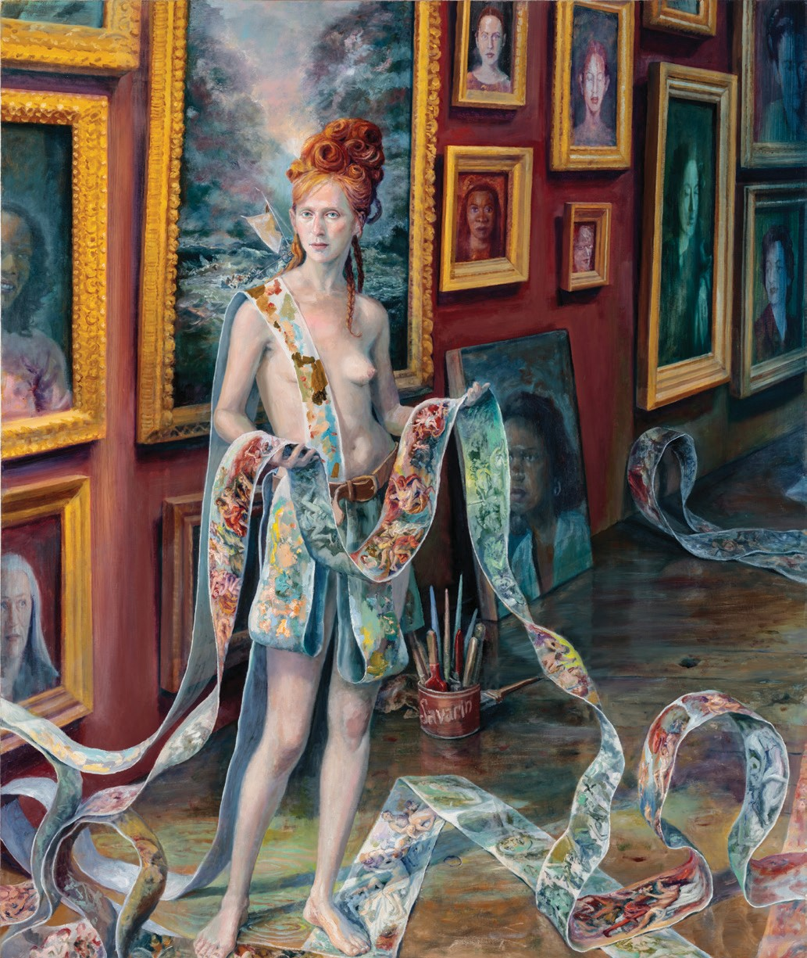
78 Maria Kochis
COURTESY CATHARINE CLARK GALLERY

